Filed under Rule 425

under the Securities Act of 1933, as amended

and deemed filed under Rule 14a-12

of the Securities Exchange Act of 1934, as amended

Filing by: New Starship Parent, Inc.

Subject Company: FTAC Olympus Acquisition Corp.
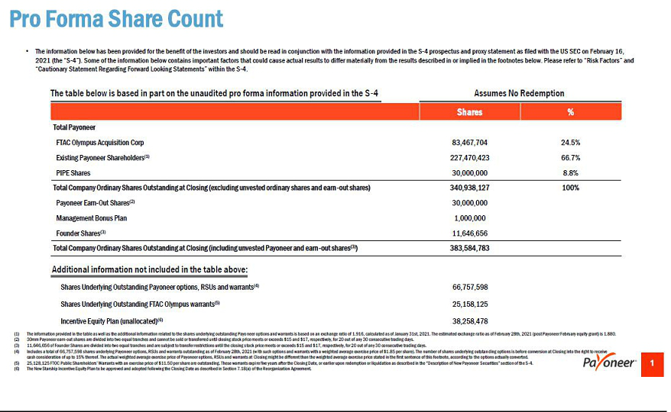

Important Information and Where to Find It

In connection with the definitive agreement and plan of reorganization (the “Reorganization”) between Payoneer Inc. (“Payoneer”) and FTAC Olympus Acquisition Corp. (“FTOC”), New Starship Parent Inc. (“New Starship”) filed with the Securities and Exchange Commission (the “SEC”) a preliminary proxy statement / prospectus on February 16, 2021 and will mail a definitive proxy statement / prospectus and other relevant documentation to FTOC stockholders. This document does not contain all the information that should be considered concerning the proposed Reorganization. It is not intended to form the basis of any investment decision or any other decision in respect of the proposed Reorganization. FTOC stockholders and other interested persons are advised to read the preliminary proxy statement / prospectus and any amendments thereto, when available, and the definitive proxy statement / prospectus in connection with the solicitation of proxies for the special meeting to be held to approve the transactions contemplated by the proposed Reorganization because these materials will contain important information about Payoneer, FTOC and the proposed transactions. The definitive proxy statement / prospectus will be mailed to FTOC stockholders as of a record date to be established for voting on the proposed Reorganization when it becomes available. Stockholders will also be able to obtain a copy of the preliminary proxy statement / prospectus and the definitive proxy statement / prospectus once it is available, without charge, at the SEC’s website at http://sec.gov or by directing a request to: FTAC Olympus Acquisition Corp., 2929 Arch Street, Suite 1703, Philadelphia, Pennsylvania 19104.

Participants in the Solicitation

Payoneer and FTOC, and their respective directors and executive officers, may be considered participants in the solicitation of proxies with respect to the potential transaction described in these materials under the rules of the SEC. Information about the directors and executive officers of FTOC is set forth in FTOC’s Prospectus dated August 25, 2020 filed with the SEC on August 26, 2020. Information regarding other persons who may, under the rules of the SEC, be deemed participants in the solicitation of the stockholders in connection with the potential transaction and a description of their interests are set forth in the proxy statement/ prospectus filed with the SEC on February 16, 2021. These documents can be obtained free of charge from the sources indicated above.

Non-Solicitation

These materials are not a proxy statement or solicitation of a proxy, consent or authorization with respect to any securities or in respect of the potential transaction and shall not constitute an offer to sell or a solicitation of an offer to buy the securities of FTOC or Payoneer, nor shall there be any sale of any such securities in any state or jurisdiction in which such offer, solicitation, or sale would be unlawful prior to registration or qualification under the securities laws of such state or jurisdiction. No offer of securities shall be made except by means of a prospectus meeting the requirements of the Securities Act of 1933, as amended.

